Create one folder in d drive:
Go to that path → cd d
→cd skv
Create a maven project using below command: →
mvn archetype:generate -DgroupId=com.skv.portal -DartifactId=SKV -DarchetypeArtifactId=maven-archetype-webapp -DinteractiveMode=false
now go to that SKV →
cd SKV
Convert this project to eclipse project: →
mvn eclipse:eclipse -Dwtpversion=2.0

Open the pom file and add below statement
<project xmlns="http://maven.apache.org/POM/4.0.0" xmlns:xsi="http://www.w3.org/2001/XMLSchema-instance"
xsi:schemaLocation="http://maven.apache.org/POM/4.0.0 http://maven.apache.org/maven-v4_0_0.xsd">
<modelVersion>4.0.0</modelVersion>
<groupId>com.skv.portal</groupId>
<artifactId>SKV</artifactId>
<packaging>war</packaging>
<version>1.0-SNAPSHOT</version>
<name>SKV Maven Webapp</name>
<url>http://maven.apache.org</url>
<properties>
<java-version>1.6</java-version>
<org.springframework-version>4.0.0.RELEASE</org.springframework-version>
<org.aspectj-version>1.7.4</org.aspectj-version>
<org.slf4j-version>1.7.5</org.slf4j-version>
<jackson.databind-version>2.2.3</jackson.databind-version>
</properties>
<dependencies>

<!-- Jackson -->
<dependency>
<groupId>com.fasterxml.jackson.core</groupId>
<artifactId>jackson-annotations</artifactId>
<version>2.4.0</version>
</dependency>
<dependency>
<groupId>com.fasterxml.jackson.core</groupId>
<artifactId>jackson-core</artifactId>
<version>2.4.2</version>
</dependency>
<dependency>
<groupId>com.fasterxml.jackson.core</groupId>
<artifactId>jackson-databind</artifactId>
<version>2.4.2</version>
</dependency>
<!-- Spring -->
<dependency>
<groupId>org.springframework</groupId>
<artifactId>spring-context</artifactId>
<version>${org.springframework-version}</version>
<exclusions>
<!-- Exclude Commons Logging in favor of SLF4j -->
<exclusion>
<groupId>commons-logging</groupId>
<artifactId>commons-logging</artifactId>
</exclusion>
</exclusions>
</dependency>
<dependency>
<groupId>org.springframework</groupId>
<artifactId>spring-webmvc</artifactId>
<version>${org.springframework-version}</version>
</dependency>

<!-- AspectJ -->
<dependency>
<groupId>org.aspectj</groupId>
<artifactId>aspectjrt</artifactId>
<version>${org.aspectj-version}</version>
</dependency>

<!-- Logging -->
<dependency>
<groupId>org.slf4j</groupId>
<artifactId>slf4j-api</artifactId>
<version>${org.slf4j-version}</version>
</dependency>
<dependency>
<groupId>org.slf4j</groupId>
<artifactId>jcl-over-slf4j</artifactId>
<version>${org.slf4j-version}</version>
<scope>runtime</scope>
</dependency>
<dependency>
<groupId>org.slf4j</groupId>
<artifactId>slf4j-log4j12</artifactId>
<version>${org.slf4j-version}</version>
<scope>runtime</scope>
</dependency>
<dependency>
<groupId>log4j</groupId>
<artifactId>log4j</artifactId>
<version>1.2.15</version>
<exclusions>
<exclusion>
<groupId>javax.mail</groupId>
<artifactId>mail</artifactId>
</exclusion>
<exclusion>
<groupId>javax.jms</groupId>
<artifactId>jms</artifactId>
</exclusion>
<exclusion>
<groupId>com.sun.jdmk</groupId>
<artifactId>jmxtools</artifactId>
</exclusion>
<exclusion>
<groupId>com.sun.jmx</groupId>
<artifactId>jmxri</artifactId>
</exclusion>
</exclusions>
<scope>runtime</scope>
</dependency>

<!-- @Inject -->
<dependency>
<groupId>javax.inject</groupId>
<artifactId>javax.inject</artifactId>
<version>1</version>
</dependency>

<!-- Servlet -->
<dependency>
<groupId>javax.servlet</groupId>
<artifactId>servlet-api</artifactId>
<version>2.5</version>
<scope>provided</scope>
</dependency>
<dependency>
<groupId>javax.servlet.jsp</groupId>
<artifactId>jsp-api</artifactId>
<version>2.1</version>
<scope>provided</scope>
</dependency>
<dependency>
<groupId>javax.servlet</groupId>
<artifactId>jstl</artifactId>
<version>1.2</version>
</dependency>

<!-- Test -->
<dependency>
<groupId>junit</groupId>
<artifactId>junit</artifactId>
<version>3.8.1</version>
<scope>test</scope>
</dependency>
<dependency>
<groupId>commons-codec</groupId>
<artifactId>commons-codec</artifactId>
<version>1.6</version>
</dependency>
<dependency>
<groupId>commons-logging</groupId>
<artifactId>commons-logging</artifactId>
<version>1.1.3</version>
</dependency>
<dependency>
<groupId>org.apache.httpcomponents</groupId>
<artifactId>fluent-hc</artifactId>
<version>4.3.1</version>
</dependency>
<dependency>
<groupId>org.apache.httpcomponents</groupId>
<artifactId>httpclient</artifactId>
<version>4.3.1</version>
</dependency>
<dependency>
<groupId>org.apache.httpcomponents</groupId>
<artifactId>httpclient-cache</artifactId>
<version>4.3.1</version>
</dependency>
<dependency>
<groupId>org.apache.httpcomponents</groupId>
<artifactId>httpcore</artifactId>
<version>4.3</version>
</dependency>
<dependency>
<groupId>org.apache.httpcomponents</groupId>
<artifactId>httpmime</artifactId>
<version>4.3.1</version>
</dependency>
</dependencies>
<build>
<plugins>
<plugin>
<artifactId>maven-eclipse-plugin</artifactId>
<version>2.9</version>
<configuration>
<additionalProjectnatures>
<projectnature>org.springframework.ide.eclipse.core.springnature</projectnature>
</additionalProjectnatures>
<additionalBuildcommands>
<buildcommand>org.springframework.ide.eclipse.core.springbuilder</buildcommand>
</additionalBuildcommands>
<downloadSources>true</downloadSources>
<downloadJavadocs>true</downloadJavadocs>
</configuration>
</plugin>
<plugin>
<groupId>org.apache.maven.plugins</groupId>
<artifactId>maven-compiler-plugin</artifactId>
<version>2.5.1</version>
<configuration>
<source>1.6</source>
<target>1.6</target>
<compilerArgument>-Xlint:all</compilerArgument>
<showWarnings>true</showWarnings>
<showDeprecation>true</showDeprecation>
</configuration>
</plugin>
<plugin>
<groupId>org.codehaus.mojo</groupId>
<artifactId>exec-maven-plugin</artifactId>
<version>1.2.1</version>
<configuration>
<mainClass>org.test.int1.Main</mainClass>
</configuration>
</plugin>

<!-- This is need when you generated the doc file -->
<!--
<plugin>
<groupId>org.apache.maven.plugins</groupId>
<artifactId>maven-source-plugin</artifactId>
<version>2.1.2</version>
<executions>
<execution>
<id>attach-sources</id>
<phase>verify</phase>
<goals>
<goal>jar-no-fork</goal>
</goals>
</execution>
</executions>
</plugin>
<plugin>
<groupId>org.apache.maven.plugins</groupId>
<artifactId>maven-javadoc-plugin</artifactId>
<version>2.10.3</version>
<executions>
<execution>
<id>attach-javadocs</id>
<phase>verify</phase>
<goals>
<goal>jar</goal>
</goals>
</execution>
</executions>
</plugin> -->
</plugins>

</build>
</project>

Import this project in eclipse:
After changes the structure:
In eclipse :
Inside main add one folder → create java folder
Inside resources add folder→ create META-INF folder and log4j.xml file that structure give below:
<?xml version="1.0" encoding="UTF-8"?>
<!DOCTYPE log4j:configuration PUBLIC "-//APACHE//DTD LOG4J 1.2//EN" "log4j.dtd">
<log4j:configuration xmlns:log4j="http://jakarta.apache.org/log4j/">

<!-- Appenders -->
<appender name="console" class="org.apache.log4j.ConsoleAppender">
<param name="Target" value="System.out" />
<layout class="org.apache.log4j.PatternLayout">
<param name="ConversionPattern" value="%-5p: %c - %m%n" />
</layout>
</appender>

<!-- Application Loggers -->
<logger name="com.skv.spring">
<level value="info" />
</logger>

<!-- 3rdparty Loggers -->
<logger name="org.springframework.core">
<level value="info" />
</logger>

<logger name="org.springframework.beans">
<level value="info" />
</logger>

<logger name="org.springframework.context">
<level value="info" />
</logger>

<logger name="org.springframework.web">
<level value="info" />
</logger>

<!-- Root Logger -->
<root>
<priority value="warn" />
<appender-ref ref="console" />
</root>

</log4j:configuration>

Inside of webapp →WEB-INF → spring→ appServlet→ servlet-context.xml
<?xml version="1.0" encoding="UTF-8"?>
<beans:beans xmlns="http://www.springframework.org/schema/mvc"
xmlns:xsi="http://www.w3.org/2001/XMLSchema-instance"
xmlns:beans="http://www.springframework.org/schema/beans"
xmlns:context="http://www.springframework.org/schema/context"
xsi:schemaLocation="http://www.springframework.org/schema/mvc http://www.springframework.org/schema/mvc/spring-mvc.xsd
http://www.springframework.org/schema/beans http://www.springframework.org/schema/beans/spring-beans.xsd
http://www.springframework.org/schema/context http://www.springframework.org/schema/context/spring-context.xsd">

<!-- DispatcherServlet Context: defines this servlet's request-processing infrastructure -->

<!-- Enables the Spring MVC @Controller programming model -->
<annotation-driven />

<!-- Handles HTTP GET requests for /resources/** by efficiently serving up static resources in the ${webappRoot}/resources directory -->
<resources mapping="/resources/**" location="/resources/" />

<!-- Resolves views selected for rendering by @Controllers to .jsp resources in the /WEB-INF/views directory -->
<beans:bean class="org.springframework.web.servlet.view.InternalResourceViewResolver">
<beans:property name="prefix" value="/WEB-INF/views/" />
<beans:property name="suffix" value=".jsp" />
</beans:bean>

<!-- Configure to plugin JSON as request and response in method handler -->
<beans:bean class="org.springframework.web.servlet.mvc.method.annotation.RequestMappingHandlerAdapter">
<beans:property name="messageConverters">
<beans:list>
<beans:ref bean="jsonMessageConverter"/>
</beans:list>
</beans:property>
</beans:bean>

<!-- Configure bean to convert JSON to POJO and vice versa -->
<beans:bean id="jsonMessageConverter" class="org.springframework.http.converter.json.MappingJackson2HttpMessageConverter">
</beans:bean>

<context:component-scan base-package="com.skv.portal.controller" />

</beans:beans>

Inside of webapp →WEB-INF → spring→ root-context.xml
<?xml version="1.0" encoding="UTF-8"?>
<beans xmlns="http://www.springframework.org/schema/beans"
xmlns:xsi="http://www.w3.org/2001/XMLSchema-instance"
xsi:schemaLocation="http://www.springframework.org/schema/beans http://www.springframework.org/schema/beans/spring-beans.xsd">

<!-- Root Context: defines shared resources visible to all other web components -->

</beans>

Web.xml file
<?xml version="1.0" encoding="UTF-8"?>
<web-app version="2.5" xmlns="http://java.sun.com/xml/ns/javaee"
xmlns:xsi="http://www.w3.org/2001/XMLSchema-instance"
xsi:schemaLocation="http://java.sun.com/xml/ns/javaee http://java.sun.com/xml/ns/javaee/web-app_2_5.xsd">

<!-- The definition of the Root Spring Container shared by all Servlets and Filters -->
<context-param>
<param-name>contextConfigLocation</param-name>
<param-value>/WEB-INF/spring/root-context.xml</param-value>
</context-param>

<!-- Creates the Spring Container shared by all Servlets and Filters -->
<listener>
<listener-class>org.springframework.web.context.ContextLoaderListener</listener-class>
</listener>

<!-- Processes application requests -->
<servlet>
<servlet-name>appServlet</servlet-name>
<servlet-class>org.springframework.web.servlet.DispatcherServlet</servlet-class>
<init-param>
<param-name>contextConfigLocation</param-name>
<param-value>/WEB-INF/spring/appServlet/servlet-context.xml</param-value>
</init-param>
<load-on-startup>1</load-on-startup>
</servlet>

<servlet-mapping>
<servlet-name>appServlet</servlet-name>
<url-pattern>/</url-pattern>
</servlet-mapping>

</web-app>

Create one folder inside store all jsp file
webapp →WEB-INF→views

N.B:
-->How to include third party jar file in maven

mvn install:install-file -Dfile=D:/bitcoin/bitcoinj-master/core/target/bitcoinj-core-0.15-SNAPSHOT.jar -DgroupId=org.bitcoinj -DartifactId=bitcoinj-core -Dversion=0.15-SNAPSHOT -Dpackaging=jar
mvn install:install-file -Dfile=D:/bitcoin/bitcoinj-master/core/target/bitcoinj-core-0.15-SNAPSHOT-bundled.jar -DgroupId=org.bitcoinj -DartifactId=bitcoinj-bundled -Dversion=0.15-SNAPSHOT -Dpackaging=jar
mvn install:install-file -Dfile=D:/bitcoin/bitcoinj-master/core/target/bitcoinj-core-0.15-SNAPSHOT-javadoc.jar -DgroupId=org.bitcoinj -DartifactId=bitcoinj-javadoc -Dversion=0.15-SNAPSHOT -Dpackaging=jar
mvn install:install-file -Dfile=D:/bitcoin/bitcoinj-master/core/target/bitcoinj-core-0.15-SNAPSHOT-sources.jar -DgroupId=org.bitcoinj -DartifactId=bitcoinj-sources -Dversion=0.15-SNAPSHOT -Dpackaging=jar

mvn install:install-file -Dfile=D:/Software/jars/peerbase-java.jar -DgroupId=org.yodlee -DartifactId=peerbase-java -Dversion=1.0 -Dpackaging=jar

mvn install:install-file -Dfile=D:/Software/jars/peerbase-java.jar -DgroupId=com.yodlee -DartifactId=example-app -Dversion=1.0 -Dpackaging=jar

If you facing any issue in run time class not loaded then goto →

Solution

Reason 1)
Possibly you have not added the spring web dependencies in your project. Just add them if you have not.

Reason 2)
If you are still getting this exception then you must add these dependencies to project deployment assemblyas well.
To add dependencies in deployment assembly follow below instructions.
1) Open project properties and select Choose Deployment Assembly. Then select option “Java Build Path Entries”.
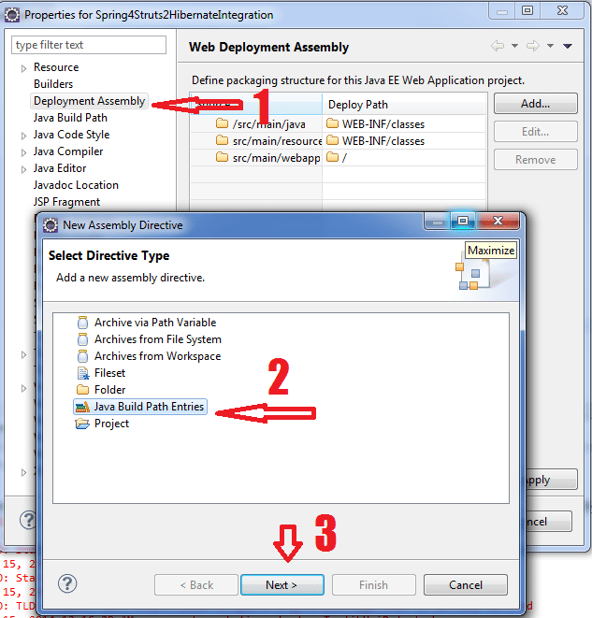
2) Click Next and select all jar files. Click Finish.
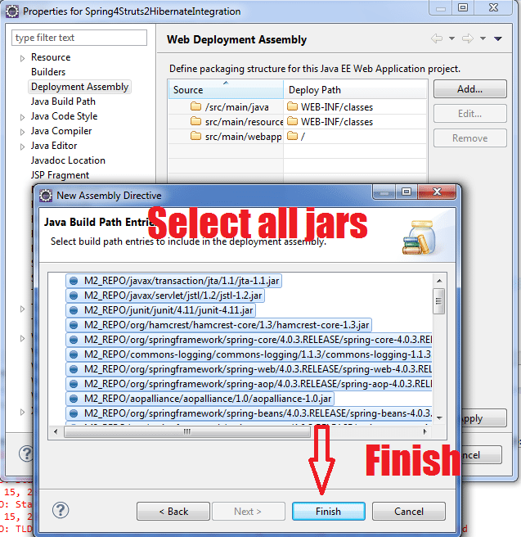
3) Deployment assembly will look like this. Click Apply.
